The other 98%
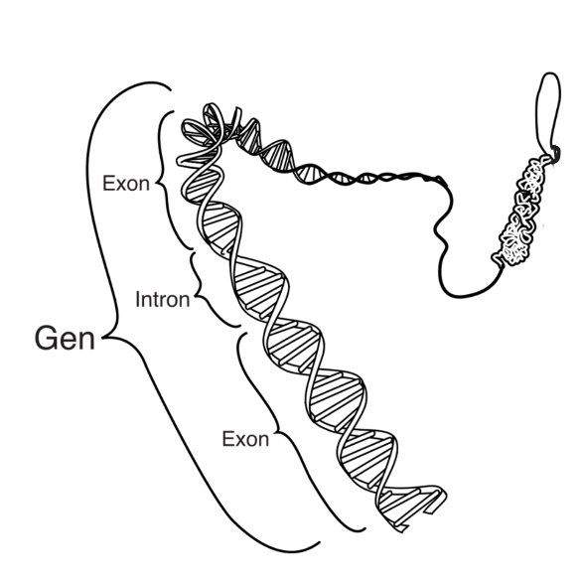

Genes are regions of DNA in your genome.
Scientists estimate that genes are only about 2% of your genome.

The table contains statements about the other 98% of your genome.
Some of the statements are right and some are wrong.
Tick one box for each statement.

Statements |  | I am sure this is right | I think this is right | I think this is wrong | I am sure this is wrong
1 | Cells use the information coded in the other 98% as instructions to make proteins.
2 | It’s just junk.
3 | Cells use the information coded in the other 98% to control when genes are used.
4 | The information coded in the other 98% can affect our characteristics.

What does the research say?
Defined simply, the genome is the entire DNA of an organism. Recent estimates suggest that genes (“coding” regions of DNA whose sequences encode the order in which amino acids are joined together to make proteins) make up less than 2% of the DNA in the genome (Pennisi, 2007); up to 80% of the remaining “non-coding” DNA – historically mischaracterised as “junk” – is important in controlling gene expression (how and when genes are used to make proteins). Most heritable traits are affected by multiple regions of coding and non-coding DNA.
Expected answers
- Cells use the information coded in the other 98% as instructions to make proteins – wrong (the information coded in genes – the 2% – is used as instructions to make proteins)
- It’s just junk – wrong (up to 80% of it is important in controlling gene expression – i.e. how and when genes are used to make proteins)
- Cells use the information coded in the other 98% to control when genes are used – right
- The information coded in the other 98% can affect our characteristics – right
How to respond - what next?
If there is a range of answers, you may choose to respond through structured class discussion. Ask one student to explain why they gave the answer they did; ask another student to explain why they agree with them; ask another to explain why they disagree, and so on. This sort of discussion gives students the opportunity to explore their thinking and for you to really understand their learning needs. Responses often work best when the activities involve paired or small group discussions, which encourage social construction of new ideas through dialogue.

Acknowledgments
Developed by Alistair Moore (UYSEG).
Images: https://nl.wikipedia.org/wiki/Gen

References
Airey, J., Moore, A. and Bennett, J. (2018). Viewed as a whole: syntheses of research evidence and teaching support resources related to genomics education in schools. A report to the Wellcome Genome Campus Public Engagement Team: University of York, UK.
Lewis, J. and Kattmann, U. (2004). Traits, genes, particles and information: re-visiting students' understandings of genetics. International Journal of Science Education, 26(2), 195-206.
Pennisi, E. (2007). DNA study forces rethink of what it means to be a gene. Science, 316(5831), 1556-1557.
Stern, F. and Kampourakis, K. (2017). Teaching for genetics literacy in the post-genomic era. Studies in Science Education, 53(2), 193-225.

